**Front-End UI/UX Mini Project**

**1. Title Page**

* **Project Title**: E learning Course Overview page
* **Submitted By**: 
  + *Team Members-*

Adi Sankar KB (2460308)

Blesson Baby (2460346)

Chris Paul (2460350)

* + *College-E-mailid-*

*adi.sankar@btech.christuniversity.in*

*blesson.baby@btech.christuniversity.in*

*chris.paul@btech.christuniversity.in*

* **Course**: *UI/UX Design Fundamentals*
* **Instructor Name**: *Dhiraj Alate.*
* **Institution**: *Christ University*
* **Date of Submission**: *12/08/2025*

**2. Abstract**

This project is a responsive web page template designed to showcase an online course in an engaging, professional, and user-friendly manner. Built using HTML5 and CSS3, the page leverages semantic markup, a modular design approach, and CSS variables for theme consistency. The interface presents essential course information—such as title, instructor bio, program modules, student reviews, and enrollment details—within visually distinct sections. Interactive hover effects, cohesive color themes, and typography from Google Fonts enhance readability and user engagement. The structure is optimized for accessibility and mobile responsiveness, ensuring a seamless experience across devices. Intended for e-learning platforms, the template can be easily customized to host multiple courses, improving marketing appeal and user conversion rates.

**3. Objectives**

* Present course information clearly with a concise, visually rich overview of content, structure, and goals.
* Enhance user engagement using modern design elements, trust badges, and student testimonials.
* Ensure a fully responsive and accessible layout for readability and usability across devices.
* Highlight instructor qualifications to build credibility and trust in course quality.
* Encourage enrollment with a prominent CTA, transparent pricing, start date, and trust indicators.
* Maintain consistent branding via a reusable CSS design system with variables for easy customization.
* Optimize for quick deployment and seamless integration into existing e-learning platforms.

**4. Scope of the Project**

* Design and develop a responsive, visually appealing course landing page using HTML5 and CSS3.
* Implement a structured layout with distinct sections for the hero banner, course overview, modules, instructor details, student reviews, and enrollment.
* Use CSS variables for consistent theming and easy customization across the project.
* Ensure cross‑device compatibility, adapting seamlessly to desktop, tablet, and mobile screens.
* Incorporate interactive visual effects such as hover animations to enhance user experience.
* Highlight trust‑building elements like badges, testimonials, and instructor credentials.
* Include an engaging call‑to‑action area with pricing, start dates, and trust indicators to encourage enrollment.
* Maintain semantic HTML elements for better accessibility, SEO, and integration into e‑learning platforms.
* Allow for easy scalability so the template can be reused for multiple courses with minimal changes.
* Optimize the design for quick loading and clean code structure for maintainability.

**5. Tools & Technologies Used**

| Tool/Technology | Purpose |
| --- | --- |
| HTML5 | Markup and content structure |
| CSS3 | Styling and layout management |
| VS Code | Code editor |
| Chrome DevTools | Testing and debugging |

**6. HTML Structure Overview**

* Used semantic tags: <header>, <nav>, <main>, <section>, <footer>
* Structured into reusable sections: About, Projects, Contact
* Navigation menu using <ul> and anchor links for smooth scrolling

**7. CSS Styling Strategy**

* Use CSS variables for colors, fonts, and spacing to make theming easy.
* Follow a structured approach with sections for base styles, layout, components, and responsive rules.
* Apply semantic class naming (like BEM) for clarity and reuse.
* Maintain a consistent color palette and typography for a diary-like feel.
* Design a responsive layout that works on all screen sizes.
* Use hover, focus, and active states for better interactivity.
* Keep editable fields visually distinct with clear focus styles.
* Style navigation for clarity and highlight active/hover states.
* Add spacing and shadows for depth without overcomplicating visuals.
* Ensure accessibility with proper contrast and visible focus indicators.

**8. Key Features**

| Feature | Description |
| --- | --- |
| Responsive Design | Adapts seamlessly to all screen sizes |
| Smooth Navigation | Fixed top nav with anchor links |
| Project Cards | Flex-based layout with hover effects |
| Contact Form (non-functional) | Placeholder layout for inputs and button |
| Accessible Fonts & Colors | High contrast and readable typography |

**9. Challenges Faced & Solutions**

| Challenge | Solution |
| --- | --- |
| Overlapping elements on small screens | Used media queries to stack elements |
| Difficulty aligning items using float | Shifted to Flexbox and Grid |
| Typography scaling issue | Used relative units (em/rem) instead of px |

**10. Outcome**

* Achieved a clean, consistent, and visually engaging front-end layout
* All key components function as intended using just HTML and CSS
* Learned about layout responsiveness and UI hierarchy in depth

**11. Future Enhancements**

* Add an intro video or animated preview in the hero section, along with richer testimonials and success stories for stronger engagement.
* Optimize performance and accessibility by improving image compression, lazy loading, color contrast, keyboard navigation, and alt text.
* Improve mobile and responsive UX with simplified navigation, larger touch targets, and prominent mobile CTAs.
* Enhance SEO and discoverability with structured headings, optimized meta tags, alt text, and schema markup.
* Provide detailed curriculum previews with collapsible modules, sample lessons, and downloadable syllabi.
* Strengthen instructor credibility with verified credentials, media mentions, and teaching philosophy videos.
* Simplify and optimize the enrollment process with shorter forms, multiple payment options, and persistent CTAs.
* Localize content for global audiences (language, currency, date formats) and support international users.
* Add analytics and A/B testing to improve CTAs, design elements, and enrollment conversion rates..

**12. Sample Code**

**E-learning Platform Overview**

<!DOCTYPE html>

<html lang="en">

<head>

<meta charset="UTF-8" />

<meta name="viewport" content="width=device-width, initial-scale=1" />

<title>E-Learning Course Overview</title>

<link href="https://fonts.googleapis.com/css2?family=Roboto:wght@400;700&display=swap" rel="stylesheet" />

<style>

:root {

--primary-color: #1877f2;

--secondary-color: #e9f6f9;

--accent-color: #24c19c;

--cta-color: #fcb900;

--text-color: #233245;

--card-bg: #ffffff;

--shadow: rgba(24, 119, 242, 0.07);

--font: 'Roboto', sans-serif;

--radius: 11px;

--transition: 0.3s ease;

}

body {

margin: 0;

font-family: var(--font);

background: var(--secondary-color);

color: var(--text-color);

line-height: 1.7;

}

header, footer {

background: var(--primary-color);

color: #fff;

padding: 1rem 2rem;

display: flex;

justify-content: space-between;

align-items: center;

font-weight: 500;

letter-spacing: 1px;

}

header .logo {

font-weight: 700;

font-size: 1.6rem;

letter-spacing: 2px;

}

nav ul {

list-style: none;

display: flex;

gap: 2rem;

margin: 0; padding: 0;

}

nav a {

color: #fff;

text-decoration: none;

font-weight: 500;

font-size: 1rem;

transition: color var(--transition), opacity var(--transition);

}

nav a:hover { color: var(--accent-color); }

main {

max-width: 1100px;

margin: 2rem auto;

padding: 0 1rem;

}

/* HERO */

.course-hero {

background: var(--card-bg);

border-radius: var(--radius);

box-shadow: 0 4px 12px var(--shadow);

display: flex; flex-wrap: wrap;

gap: 1.8rem;

padding: 2.2rem;

align-items: center;

}

.course-hero img {

border-radius: var(--radius);

max-width: 340px;

width: 100%;

object-fit: cover;

box-shadow: 0 4px 18px rgba(36,193,156,0.07);

transition: transform .4s ease;

}

.course-hero img:hover { transform: scale(1.04); }

.course-hero-content {

flex:1 1 330px;

}

.course-title {

font-size: 2.6rem;

font-weight: 700;

color: var(--primary-color);

margin: 0 0 .7rem 0;

}

.instructor-name {

font-size: 1.15rem;

font-weight: 600;

color: var(--accent-color);

margin-bottom:.6rem;

}

.trust-badges {

margin-top: 1rem;

display: flex;

gap: .8rem;

}

.badge {

background: var(--accent-color);

color: #fff;

font-size: .9rem;

border-radius: 20px;

padding: .4em 1.3em;

font-weight: 700;

letter-spacing: 1px;

box-shadow: 0 1px 4px rgba(36,193,156,0.14);

}

/* DESCRIPTION */

.course-description {

background: var(--card-bg);

border-radius: var(--radius);

box-shadow: 0 4px 12px var(--shadow);

padding: 2rem;

margin-top: 2rem;

}

.course-description h2 {

margin:0 0 .7rem;

font-size: 1.7rem;

color: var(--primary-color);

}

.course-description p {

font-size: 1.1rem;

margin-top: 1rem;

color: var(--text-color);

}

/* MODULES */

.course-modules {

margin-top: 2rem;

}

.course-modules h2 {

font-size: 1.7rem;

color: var(--primary-color);

margin-bottom: 1rem;

}

.modules-list {

display: grid;

grid-template-columns: repeat(auto-fit,minmax(220px,1fr));

gap: 1.3rem;

}

.module-card {

background: var(--card-bg);

border-radius: var(--radius);

display: flex;

align-items: center;

gap: 1rem;

padding: 1.4rem 1rem;

box-shadow: 0 4px 10px var(--shadow);

transition: box-shadow var(--transition), transform var(--transition);

position: relative;

}

.module-card:hover { box-shadow: 0 8px 28px rgba(24,119,242,.11); transform: translateY(-6px);}

.module-icon {

width: 44px; height:44px;

background: var(--primary-color);

border-radius: 50%;

color: #fff;

font-weight: bold;

font-size: 1.1rem;

display:flex;align-items:center;justify-content:center;

margin-right:.5em;

}

.module-title { font-weight: 700; }

/* INSTRUCTOR */

.instructor-bio {

background: var(--card-bg);

border-radius: var(--radius);

box-shadow: 0 4px 12px var(--shadow);

padding: 2rem;

margin-top: 2rem;

display: flex; flex-wrap: wrap;

gap: 2rem;

align-items: center;

}

.instructor-image {

border-radius: 50%;

width: 120px; height:120px; object-fit: cover;

background:#eee;

box-shadow: 0 2px 12px var(--shadow);

}

.instructor-details h3 {

margin: 0 0 .4rem;

color: var(--primary-color);

font-size: 1.3rem;

font-weight: bold;

}

.instructor-details p {

font-size: 1.08rem;

color: var(--text-color);

margin:0;

}

/* REVIEWS */

.student-reviews {

margin-top: 2rem;

}

.student-reviews h2 {

font-size: 1.7rem;

color: var(--primary-color);

margin-bottom: 1rem;

}

.reviews-list {

display: grid;

grid-template-columns: repeat(auto-fit,minmax(300px,1fr));

gap: 1.3rem;

}

.review-card {

background: var(--card-bg);

border-radius: var(--radius);

box-shadow: 0 4px 12px var(--shadow);

padding: 1.2rem 1rem;

transition: transform var(--transition), box-shadow var(--transition);

}

.review-card:hover { transform: scale(1.03); box-shadow:0 8px 32px rgba(36,193,156,0.10);}

.review-rating { color: var(--accent-color); font-weight:600;}

.review-author { font-weight:500; color:#666;margin-top:.5em; }

/* ENROLLMENT */

.enrollment {

background: var(--card-bg);

border-radius: var(--radius);

box-shadow: 0 6px 20px rgba(0,0,0,0.06);

padding: 2.5rem 1.5rem;

text-align: center;

margin-top: 2.5rem;

border: 2px solid var(--accent-color);

}

.enrollment h2 {

font-size: 2rem;

font-weight: 700;

color: var(--primary-color);

margin-bottom: 1.2rem;

}

.enrollment-details {

margin: 1rem 0 1.5rem;

}

.enrollment-price {

font-size: 2.4rem;

font-weight: 800;

color: var(--cta-color);

margin: 0.2rem 0;

}

.enrollment-start {

font-size: 1.15rem;

color: #555;

}

.btn-enroll {

background: var(--accent-color);

border: none;

padding: 1rem 3rem;

border-radius: 50px;

font-size: 1.2rem;

font-weight: 700;

color: #fff;

cursor: pointer;

letter-spacing: 0.5px;

transition: background var(--transition), transform var(--transition);

box-shadow: 0 6px 18px rgba(36,193,156,0.3);

margin-bottom: 1rem;

}

.btn-enroll:hover {

background: var(--cta-color);

color: var(--text-color);

transform: scale(1.05);

}

.trust-indicator {

margin-top: 0.8rem;

font-size: 0.95rem;

font-weight: 500;

color: var(--primary-color);

}

/* FOOTER */

footer {

background: var(--primary-color);

padding: 1rem;

text-align: center;

color: #d0d0d0;

font-size: .97rem;

}

footer ul { display:flex; gap:1.5rem; justify-content:center; padding:0; list-style: none; margin:0 0 .5rem;}

footer a { color: #fff; text-decoration:none; font-weight:500;}

footer a:hover {opacity: .8;}

@media(max-width:900px){

.course-hero {flex-direction:column; text-align: center;}

.course-hero img{margin-bottom:1em;}

.instructor-bio {flex-direction:column; text-align:center;}

.instructor-image {margin-bottom:1em;}

}

</style>

</head>

<body>

<header>

<div class="logo" aria-label="Platform Logo">EduPlatform</div>

<nav aria-label="Navigation">

<ul>

<li><a href="#">Courses</a></li>

<li><a href="#">About</a></li>

<li><a href="#">Support</a></li>

<li><a href="#">Contact</a></li>

</ul>

</nav>

</header>

<main>

<!-- Course Hero Section -->

<section class="course-hero">

<img src="https://www.creativeitinstitute.com/images/course/course_1663052056.jpg" alt="Course Banner Image" />

<div class="course-hero-content">

<h1 class="course-title">Mastering Web Development</h1>

<p class="instructor-name">Instructor: Jane Doe</p>

<div class="trust-badges">

<span class="badge">Certified</span>

<span class="badge">Best Seller</span>

<span class="badge">Beginner Friendly</span>

</div>

</div>

</section>

<!-- Course Description -->

<section class="course-description">

<h2>Course Overview & Objectives</h2>

<p>Learn modern web development skills from scratch: HTML, CSS, JavaScript, front-end frameworks, and deployment strategies. Our clear, practical approach means you build real projects and gain industry-ready confidence.</p>

<p>By the end, you'll be able to craft responsive, dynamic, and accessible sites — plus you'll get a completion certificate.</p>

</section>

<!-- Course Modules -->

<section class="course-modules">

<h2>Course Modules</h2>

<div class="modules-list">

<div class="module-card">

<div class="module-icon">1</div>

<div class="module-title">Introduction to HTML</div>

</div>

<div class="module-card">

<div class="module-icon">2</div>

<div class="module-title">CSS Fundamentals</div>

</div>

<div class="module-card">

<div class="module-icon">3</div>

<div class="module-title">JavaScript Essentials</div>

</div>

<div class="module-card">

<div class="module-icon">4</div>

<div class="module-title">React Framework Basics</div>

</div>

<div class="module-card">

<div class="module-icon">5</div>

<div class="module-title">Backend API Integration</div>

</div>

<div class="module-card">

<div class="module-icon">6</div>

<div class="module-title">Deployment & Best Practices</div>

</div>

</div>

</section>

<!-- Instructor Bio -->

<section class="instructor-bio">

<img class="instructor-image" src="https://images.pexels.com/photos/1130626/pexels-photo-1130626.jpeg?auto=compress&w=160&h=160&fit=crop" alt="Instructor Jane Doe" />

<div class="instructor-details">

<h3>Jane Doe</h3>

<p>Jane Doe is a senior web developer with more than a decade of experience working with Fortune 500 companies and startups. She's passionate about mentoring aspiring developers and simplifies complex topics with real-world examples.</p>

</div>

</section>

<!-- Student Reviews -->

<section class="student-reviews">

<h2>What Students Say</h2>

<div class="reviews-list">

<article class="review-card">

<p class="review-text">“Engaging lessons and lots of practice projects. Landed my first developer role thanks to this!”</p>

<div class="review-author">– Alex P.</div>

<div class="review-rating">★★★★★</div>

</article>

<article class="review-card">

<p class="review-text">“Jane explains concepts so clearly and the course is very well organized!”</p>

<div class="review-author">– Maria L.</div>

<div class="review-rating">★★★★☆</div>

</article>

<article class="review-card">

<p class="review-text">“Love the module cards and how interactive the class feels. Highly recommend.”</p>

<div class="review-author">– Samir F.</div>

<div class="review-rating">★★★★★</div>

</article>

</div>

</section>

<!-- Enrollment Section -->

<section class="enrollment">

<h2>Ready to Join?</h2>

<!-- Price & Start Date -->

<div class="enrollment-details">

<p class="enrollment-price">$199</p>

<p class="enrollment-start">Starts: September 15, 2025</p>

</div>

<!-- CTA Button -->

<button class="btn-enroll">🚀 Enroll Now</button>

<!-- Trust Points -->

<div class="trust-indicator">✅ Secure Payment&nbsp;&nbsp;|&nbsp;&nbsp;📜 Certificate on Completion&nbsp;&nbsp;|&nbsp;&nbsp;💻 Lifetime Access</div>

</section>

</main>

<footer>

<nav>

<ul>

<li><a href="#">Support</a></li>

<li><a href="#">Terms</a></li>

<li><a href="#">Privacy</a></li>

<li><a href="#">Contact</a></li>

</ul>

</nav>

<p>© 2025 EduPlatform. All rights reserved.</p>

</footer>

</body>

</html>

**13. Screenshots of Final Output**

**English version (in desktop)**

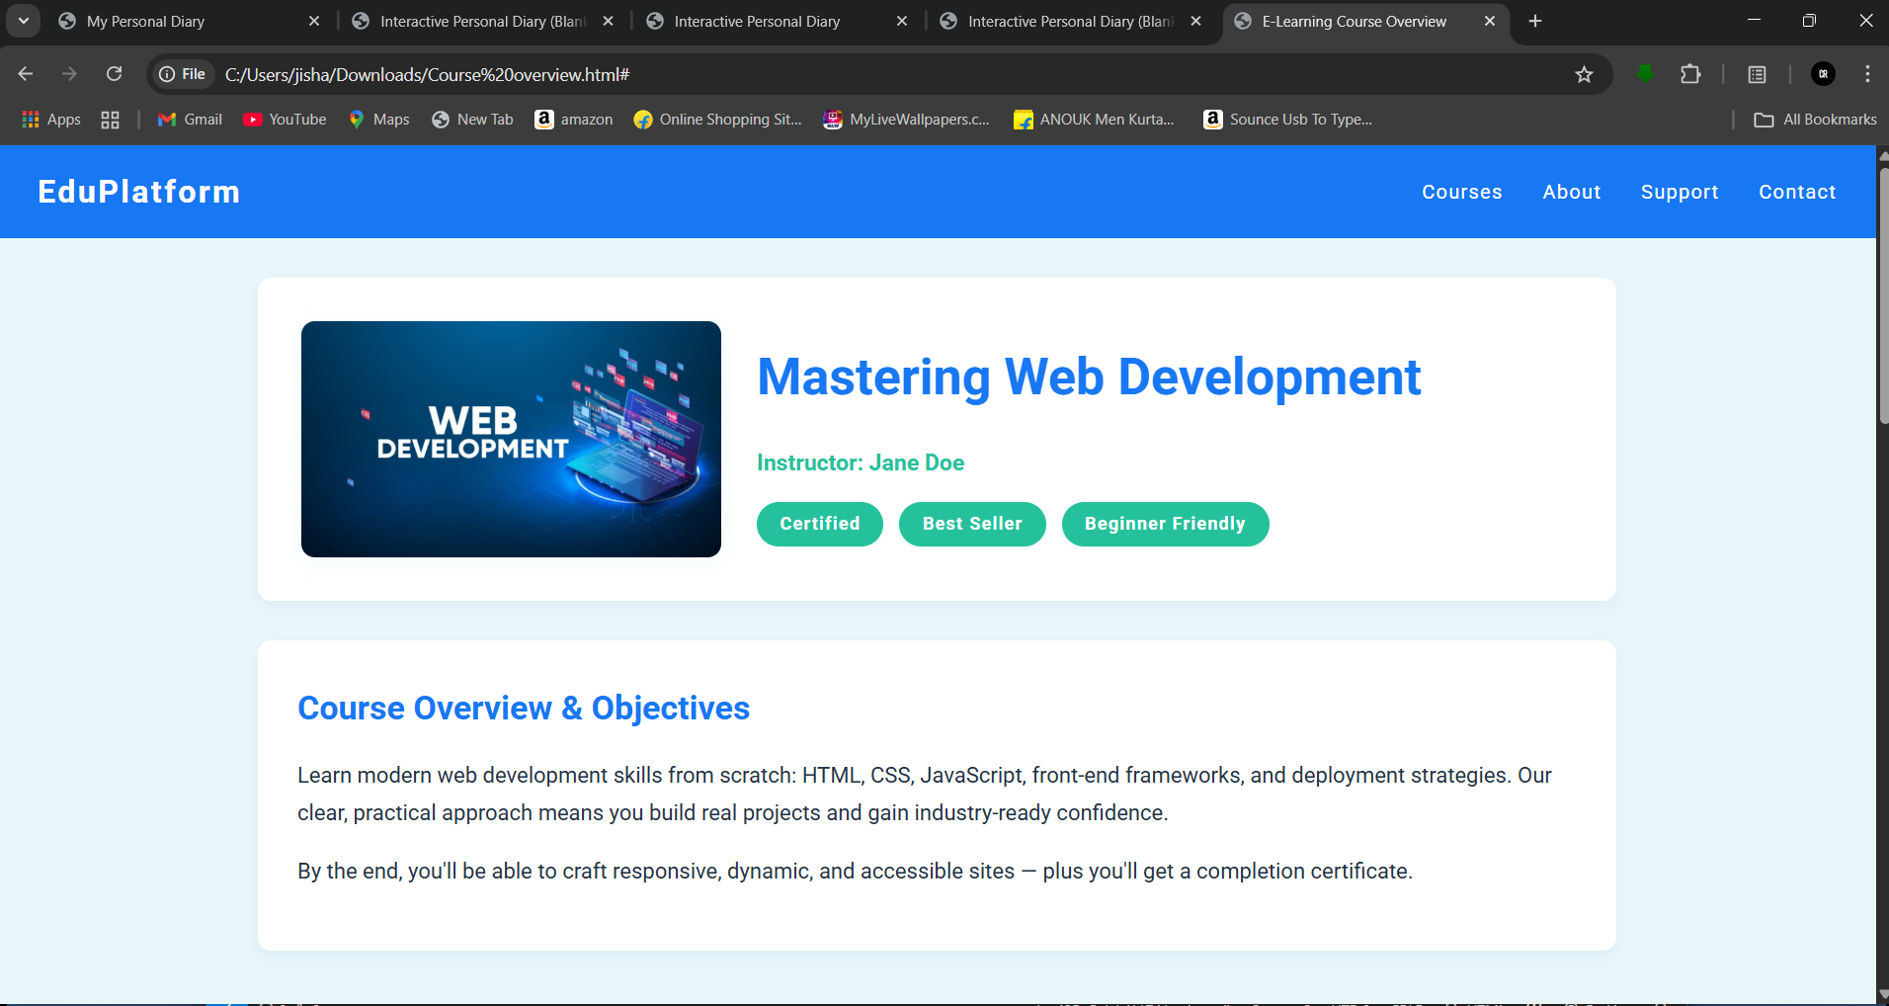

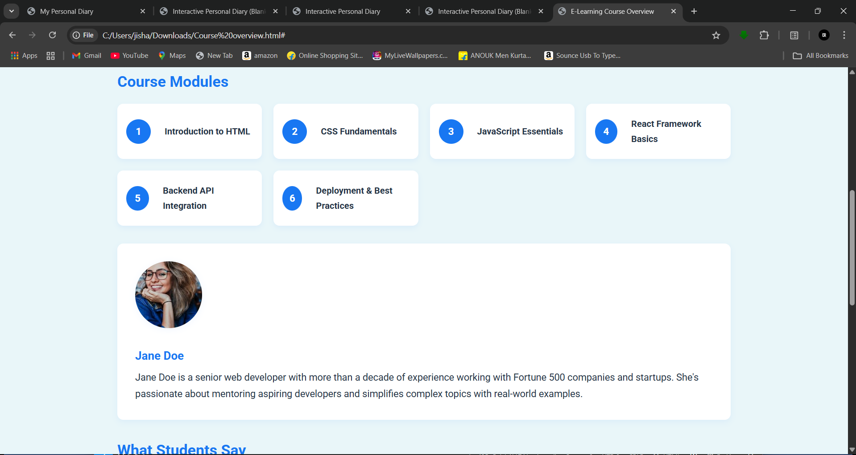

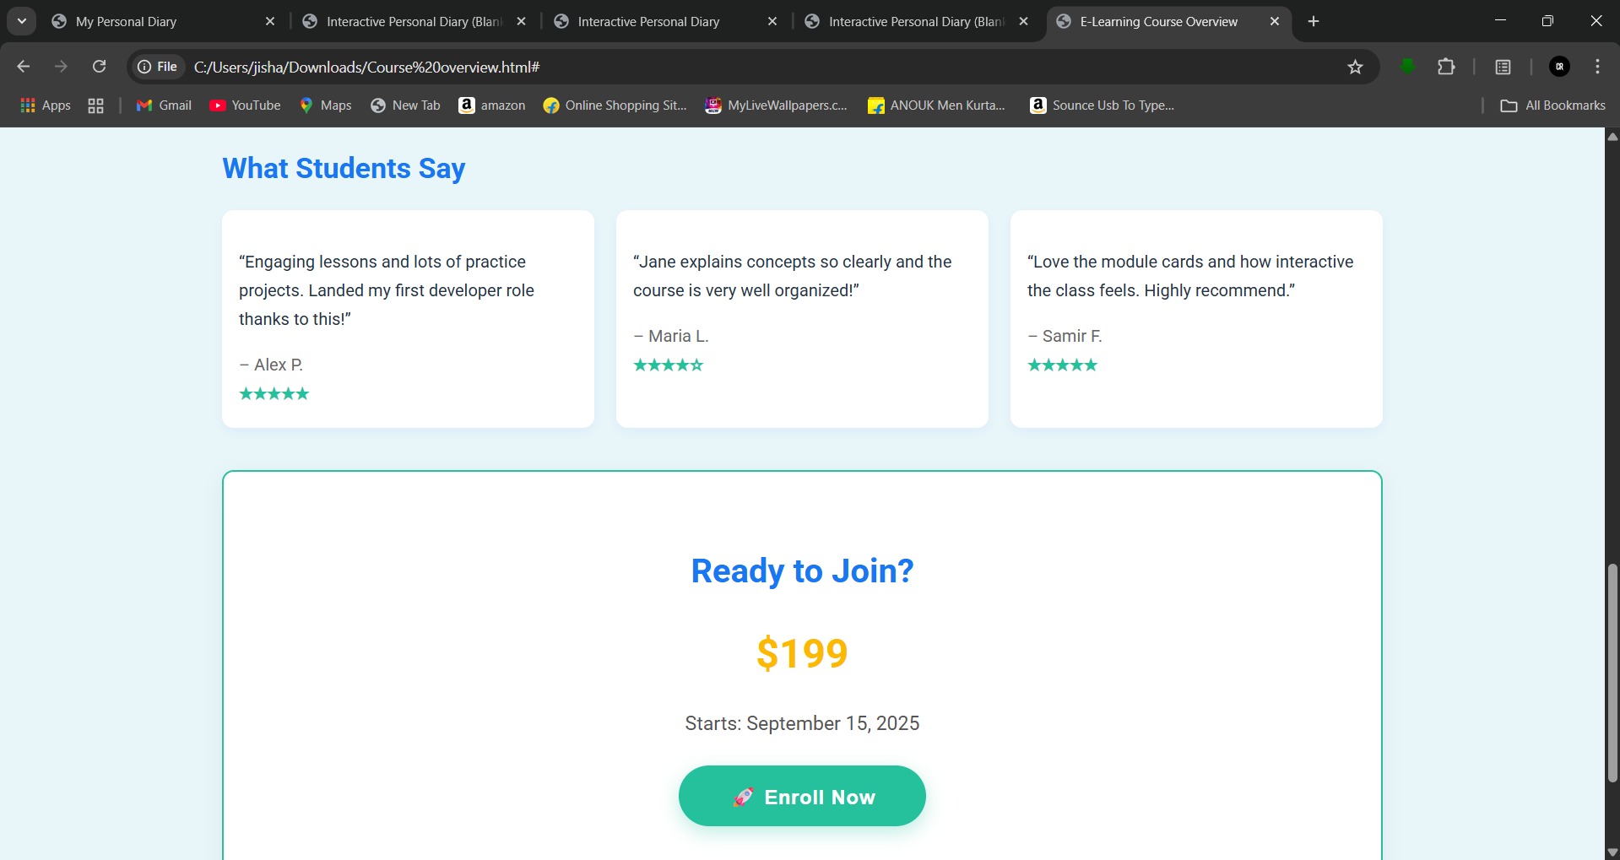

**11. Conclusion**

This project successfully delivers a modern, responsive, and visually engaging course landing page that clearly presents content, instructor details, learner testimonials, and a compelling enrollment call‑to‑action. By combining clean HTML5 semantics, structured CSS with reusable variables, and thoughtful UI elements, the design ensures accessibility, brand consistency, and ease of customization. It is scalable for use across multiple courses and adaptable to various e‑learning platforms. With future enhancements such as richer media, performance optimizations, and advanced analytics, the page can further improve user engagement, trust, and enrollment conversion rates, making it a valuable asset for online education providers.

**12. References**

* L&T LMS : https://learn.lntedutech.com/Landing/MyCourse